**TCO calculations**

1)FORECASTING COST: -

We are going to use AWS forecasting to calculate the pricing.

Now just solely going as per the training data provided to us, there was a CSV file of 135 MB containing entries of 12 days, so approximately, let’s consider 400MB of data per month and using our algorithm, which let’s assume 6 hrs of training per week.

Let’s say the number of entry points is .8million *3 (using the training data), so around 2.5 million data points per week.

Now assume hourly forecast over a 2-day horizon with a forecast frequency of 2 per day.

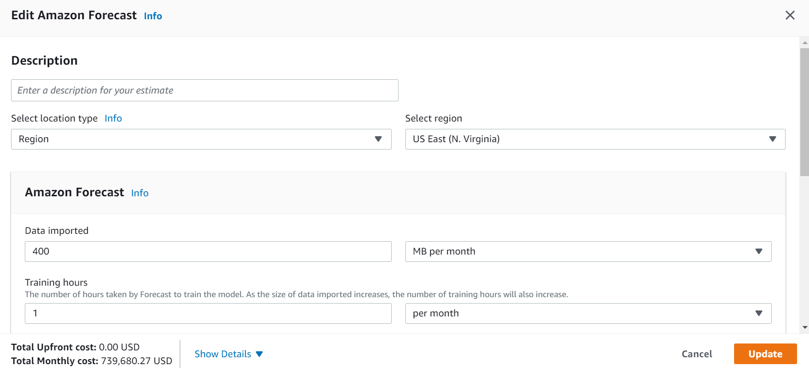

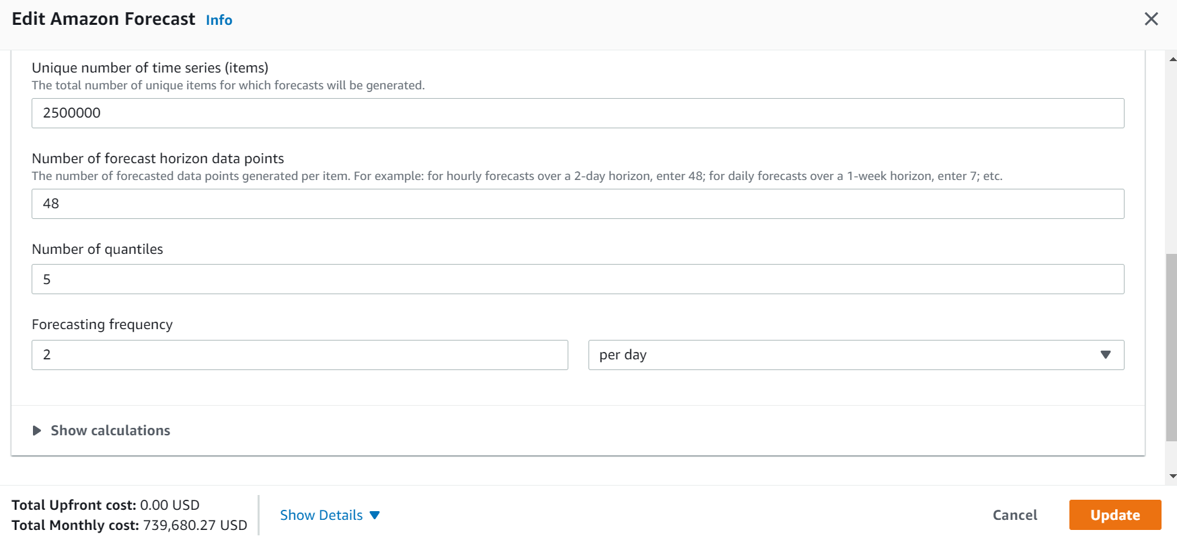

**Results of AWS forecasting: -**

Unit conversions

* Data imported: 400 MB per month x 0.0009765625 GB in a MB = 0.390625 GB per month
* Forecasting frequency: 2 per day * (730 hours in a month / 24 hours in a day) = 60.83 forecasts per month

Pricing calculations

Rounding (1) = 1 Rounded total training hours

0.390625 GB x 0.088 USD = 0.034375 USD per month

**The monthly cost for data Imported: 0.034375 USD**

1 training hours x 0.24 USD = 0.24 USD per month

**The monthly cost for Training Hours: is 0.24 USD**

2,500,000 item IDs x 48 data points or forecast horizons x 5 quantiles x 60.83 forecasts per month = 36,498,000,000 time series

36,498,000,000 time series / 1000 time series = 36,498,000 time series (per 1000)

Rounding (36498000) = 36498000 Rounded time series per thousand

Tiered price for 36498000-time series

100 time series x 2.0000000000 USD = 200.00 USD

900 time series x 0.8000000000 USD = 720.00 USD

49000 time series x 0.2000000000 USD = 9800.00 USD

36448000 time series x 0.0200000000 USD = 728960.00 USD

Total tier cost: 200.00 USD + 720.00 USD + 9800.00 USD + 728960.00 USD = 739680.00 USD per month

**The monthly cost for forecast data points: 739,680 USD**

0.034375 USD + 0.24 USD per month + 739,680 USD = 739,680.274375 USD

**Forecast Cost (monthly): 739,680.27 USD**

2)COMPUTING PLATFORM PRICING: -

We calculated the forecasting cost on the AWS server, but we also need the cost of the technology required. So, we will use AWS EC2 pricing.

Amazon EC2 offers the broadest and deepest computing platform with a choice of processor, storage, networking, operating system, and purchase model.

**NOTE:- this purchase model is based on just assumptions of the number of GPUs, memory, and quantiles required for our forecasting; this doesn’t represent the actual TCO, it’s just a simulation based on assumptions.**

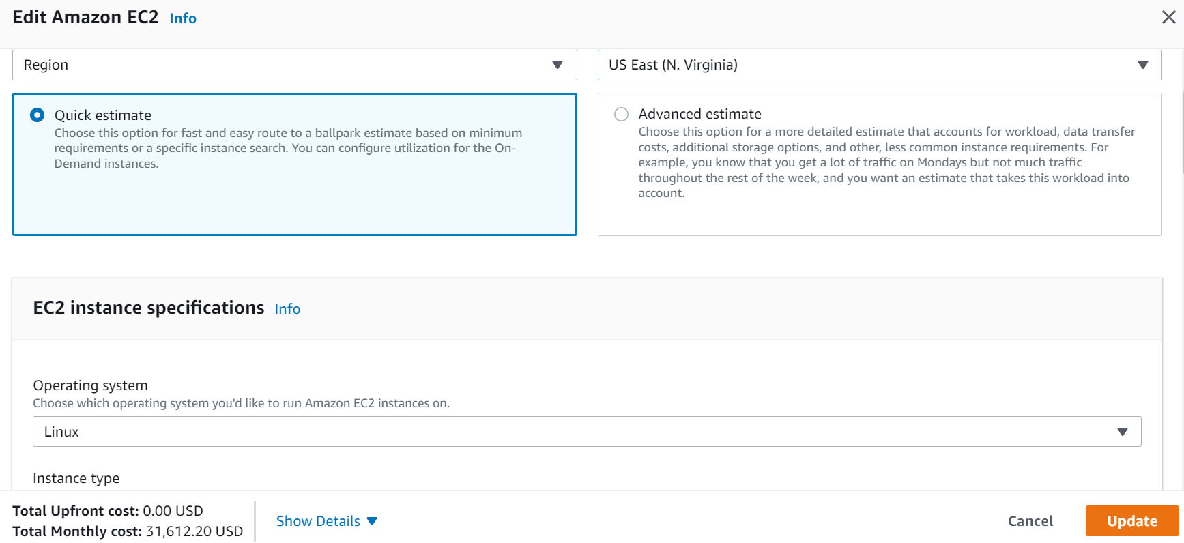

Hence,

3 instances x 14.40 USD x 730 hours in a month = 31,536.00 USD (monthly OnDemand cost)

**Amazon EC2 On-Demand instances (monthly): 31,536.00 USD**

254 GB x 0.10 USD x 3 instances = 76.20 USD (EBS Storage Cost)

**EBS Storage Cost: 76.20 USD**

**Amazon Elastic Block Storage (EBS) pricing (monthly): 76.20 USD**

**SO FINAL PRICING,**

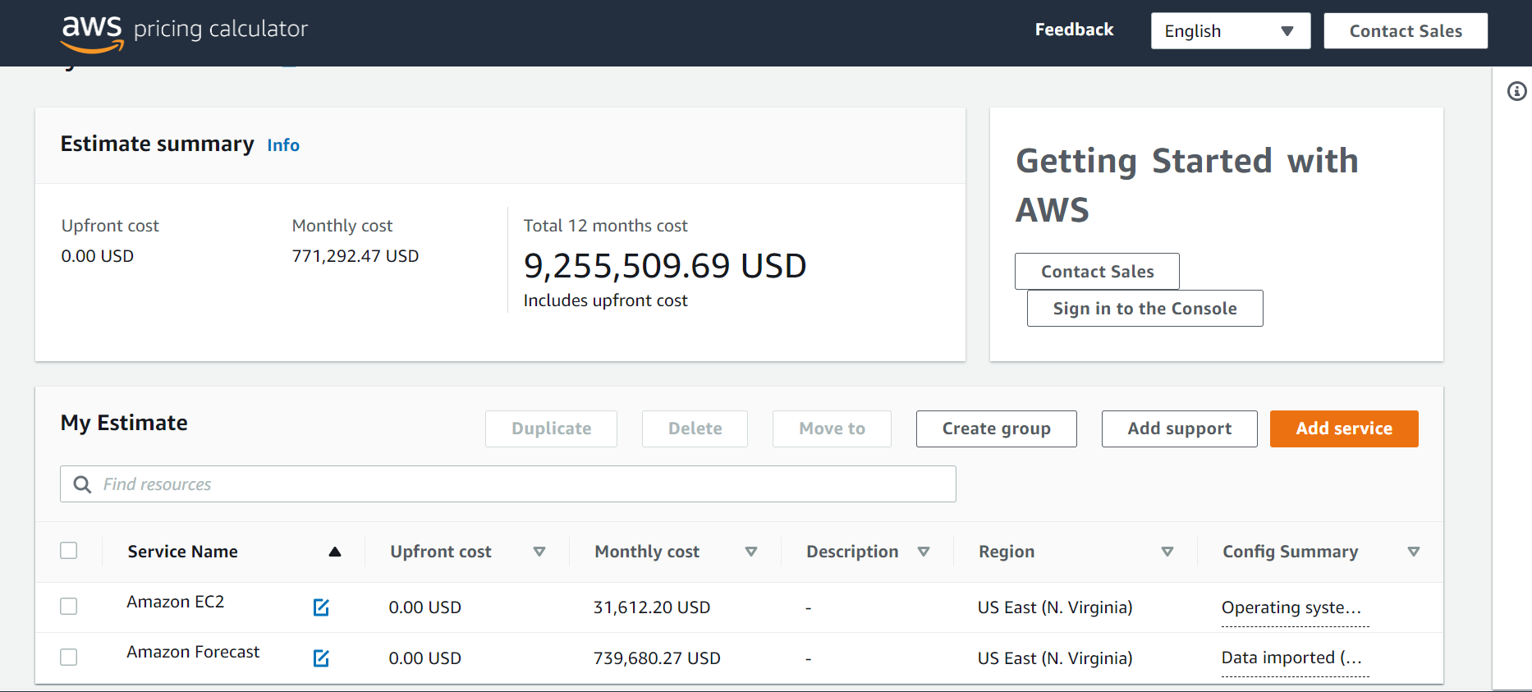

**ASSUMPTION: - THE ML MODEL’S FRONTEND IS ALREADY HOSTED ON THE SERVER, AND THEN AFTER THAT, THE PRICING IS CALCULATED.**

3)WELDING MACHINE TCO (OVER A SPAN OF 5 YEARS): -

* INITIAL COST(I)=PURCHASE COST OF THE MACHINE
* OPERATING COST(O)=COST OF INSTALLATION+ENERGY & FUEL COST
* TRAINING COST(T)= COST OF TRAINING THE EMPLOYEE TO USE THE MACHINE
* LABOR COST(L) OF THE EMPLOYEE
* MAINTAINANCE COST(M) = REGULAR REPAIRS & SERVICES
* REMAINING VALUE(R)= THE VALUE OF THE MACHINE AFTER 5 YEARS (THIS ASSUMES THAT THE MACHINE’S PURCHASE COST IS NOT SUNK COST)

**TCO=I+O+T+L+M-R**

Here the energy and fuel costs, labor costs, and maintenance costs are dynamic costs and thus increase over time with the inflation rate.